NEURALSEEK
LLM API-Level Tuning
How the Send To LLM node controls prompts, generation parameters, caching, and message overrides on a per-call basis.
NeuralSeek’s Send To LLM node is the API-level integration point where text from upstream nodes is bundled with optional prompts, parameters, and image inputs and dispatched to a chosen LLM. Every field on this node is an opportunity to tune behavior — from response shape to safety to cost. This document walks through each control and explains why it matters in production.

The Send To LLM Node
The screenshot below shows the full configuration surface for a Send To LLM node. Each labeled field is described in the sections that follow.
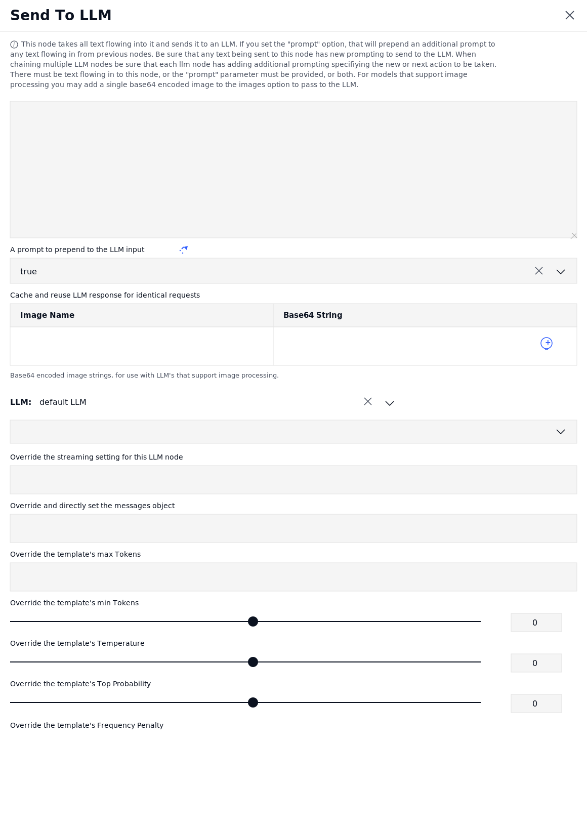
Figure: Send To LLM node — mAIstro flow editor

Prompting & Input
Text Input (incoming flow)
What it does. The large text area at the top represents whatever text is flowing into this node from upstream nodes in the mAIstro flow. The node will not fire unless either this incoming text or the prompt-prepend field has a value.
Why it matters. This is the primary message body. In a multi-step agentic flow, a previous node’s output (a search result, a classification, a transformed query) becomes the next LLM’s input. Treat it as the user-turn payload of an OpenAI-style chat call.
A prompt to prepend to the LLM input
What it does. A static or dynamic prompt that is concatenated to the front of the incoming text before the call is made. When chaining multiple LLM nodes, this is where each node’s instruction lives.
Why it matters. Without a fresh prompt at each hop, chained LLM calls drift — the model simply re-ingests the previous output with no new direction. Setting a clear prepend at every node keeps multi-turn reasoning on rails and is the single most reliable lever for steering behavior without changing the model.
Image inputs (Image Name / Base64 String)
What it does. Optional table for attaching a single base64-encoded image to the request. Only used with multimodal LLMs that accept images.
Why it matters. Multimodal calls cost more per request and only work on a subset of providers. Restricting to a single, named image keeps the request payload predictable and prevents accidental fan-out of image tokens that would blow up cost or time-out the call.

Caching
Cache and reuse LLM response for identical requests
What it does. When set to true, NeuralSeek hashes the full request (prompt + input + parameters + image) and returns the previously generated response instead of re-calling the LLM for an exact match.
Why it matters. Identical requests are surprisingly common in production — retried webhooks, reloaded pages, deterministic workflow steps. Caching converts those into zero-token, sub-millisecond responses, which compounds into real cost reduction at scale and removes a class of latency spikes from the user experience.

Model Selection
LLM
What it does. Selects which configured LLM connection this node will call. "default LLM" routes to whichever model is set as default for the relevant function in the Configure tab; otherwise pick a named connection (e.g. a specific watsonx.ai or Bedrock provider).
Why it matters. Different steps in a flow benefit from different models — a fast, cheap model for classification, a stronger model for final generation. Per-node model selection lets you load-balance for cost and latency without sacrificing quality where it counts.

Per-Call Parameter Overrides
These overrides take precedence over the Configure-tab defaults for this single node. Leaving them blank inherits the global setting; setting them locks behavior for this specific call.
Override the streaming setting for this LLM node
What it does. Forces this node to either stream tokens incrementally or wait for a full response, regardless of the global streaming configuration.
Why it matters. Streaming is great for chat UIs (perceived latency drops) but useless when the next node in a flow needs the complete response before it can act. Per-node control lets you stream to the user-facing endpoint while keeping internal flow nodes blocking.
Override and directly set the messages object
What it does. Bypasses NeuralSeek’s prompt assembly and lets you pass a raw chat-completion-style messages array (system / user / assistant turns) directly to the API.
Why it matters. Useful when you need precise control over conversation history, system prompts, or function-calling payloads. This is an escape hatch — use sparingly, because it sidesteps NeuralSeek’s built-in safety prompting and prompt-injection mitigations.
Override the template’s max Tokens
What it does. Caps the number of tokens the LLM is allowed to generate in its response.
Why it matters. Max tokens is the most direct cost and latency control on the call. Set it tight for short classifications or yes/no answers; set it generously only for long-form generation. A surprisingly common production bug is unbounded max-tokens producing 4,000-token responses to questions that needed 20 words.
Override the template’s min Tokens
What it does. Forces the LLM to produce at least this many tokens before stopping. Default 0.
Why it matters. Useful when downstream parsing depends on a minimum-length response (e.g. a JSON object that must include certain fields). Most LLMs will dutifully respond with one token if min is unset and the question is trivial — setting a floor avoids edge-case truncation.
Override the template’s Temperature
What it does. Controls randomness in token sampling. 0 is fully deterministic (greedy); higher values introduce more variation.
Why it matters. Lower temperature = more reproducible answers, better for retrieval-augmented Q&A, classification, and structured output. Higher temperature = more creative phrasing, better for brainstorming or paraphrase. Per-node control lets a flow run deterministic for extraction and creative for summarization in the same pipeline.
Override the template’s Top Probability (top-p)
What it does. Restricts token sampling to the smallest set of candidates whose cumulative probability exceeds top-p.
Why it matters. Top-p and temperature interact — most teams pick one as the primary lever and pin the other. Top-p narrows the vocabulary the model can draw from, which is an effective way to reduce wandering or off-topic content without flattening the distribution as harshly as setting temperature to 0.
Override the template’s Frequency Penalty
What it does. Penalizes tokens that have already appeared in the response, reducing the likelihood of literal repetition.
Why it matters. In long-form generation, models sometimes loop or restate phrases verbatim. A small frequency penalty (0.2–0.5) breaks that pattern without degrading quality. Too high and the response loses natural cadence; this is a fine-tuning dial, not a default.

Best Practices
- Set a deliberate prompt at every LLM node. In multi-LLM flows, leaving the prepend blank causes drift. Each hop should re-state its purpose to the model.
- Cache by default; bypass only for fresh-data calls. Caching is almost always the right default. Disable it explicitly for nodes that depend on changing context (current time, live inventory).
- Pin temperature to 0 for retrieval / extraction. Determinism matters more than creativity when the answer is grounded in source documents. Save temperature > 0 for explicit summarization or rewriting nodes.
- Use max-tokens as a cost guardrail. Cap every node to the minimum it needs. This is the cheapest abuse-and-mistake mitigation available.
- Reserve "Override messages object" for true edge cases. It bypasses NeuralSeek’s safety prompting, prompt-injection mitigation, and source-attribution scaffolding. Use only when the flow genuinely needs raw API control.

